# 1. Hardware Components:

1. RPI  
   [Link](https://www.raspberrypi.com/products/raspberry-pi-4-model-b/specifications)
2. RPI Camera  
   [Link](https://hallroad.org/8mp-raspberry-pi-camera-module-v2-in-pakistan.html)
3. Fingerprint sensor R307  
   [Link](https://hallroad.org/finger-print-sensor-r307-in-pakistan.html)
4. USB Microphone  
   [Link](https://www.razer.com/streaming-microphones/razer-seiren-mini/RZ19-03450100-R3U1)

# 2. Hardware connections

## RPI

Just power it up using any USB-C cable and power adapter.

## RPI camera

Connect the camera to board in slot as below.

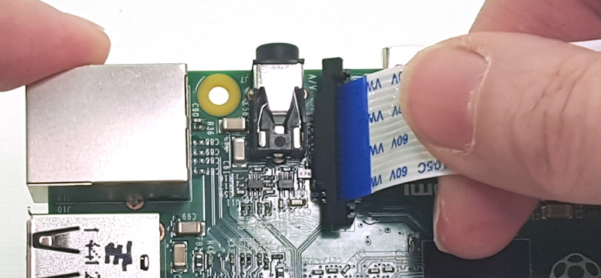

## Fingerprint sensor

Connect the sensor as follows:

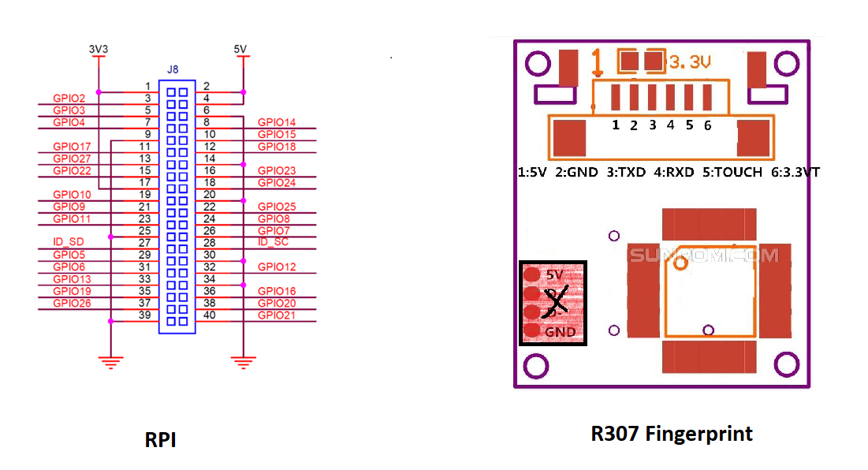

|  |  |
| --- | --- |
| RPI Pins | R307 Fingerprint Pins |
| 1 | 1 |
| 6 | 2 |
| 10 (GPIO15) | 3 |
| 8 (GPIO14) | 4 |
| NC | 5 |
| 17 | 6 |

<https://datasheets.raspberrypi.com/rpi4/raspberry-pi-4-datasheet.pdf>

## USB Microphone

Microphone is plug and play. Just connect it in USB slot.

# 3. Software libraries

## 1. Python

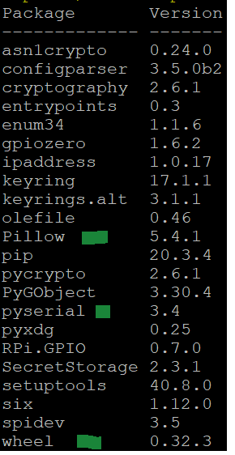

## 2. Python 3

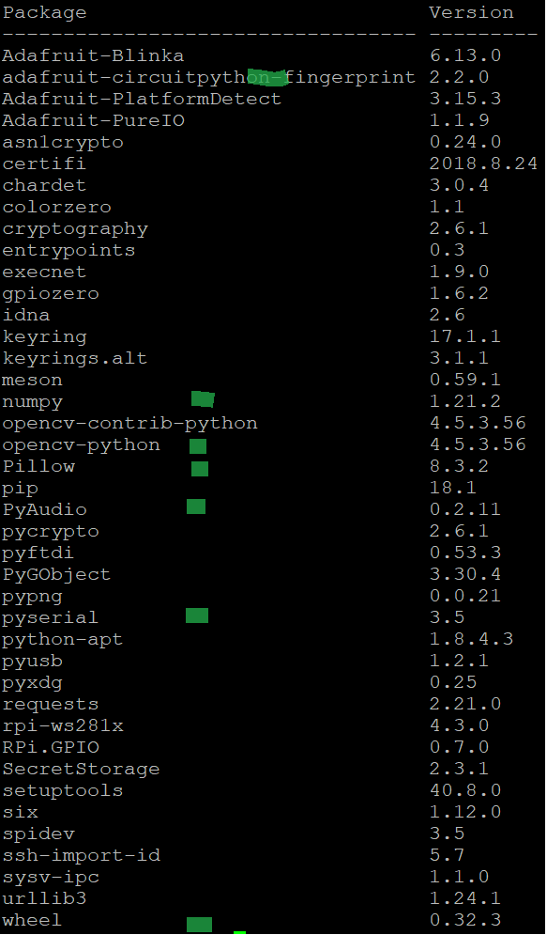

# 4. Code

Code is uploaded to my git repo